Assignments Configuration Automation using Ansible
BASICS STEPS
STEP 1 – Create EC2 Instance (AWS)
- Login to AWS Console
- Go to AWS Console
- Open EC2 service
- Click Launch Instance

STEP 2 – Create Multiple EC2s
You should create 3 EC2 instances:
EC2 Purpose
EC2-1 Ansible Control Node
EC2-2 Java + Maven Server
EC2-3 Docker / Nginx Server

Connect all ec2 using same key
Use MobaXterm to connect all

STEP 3 – Connect EC2 Using MobaXterm
- Get EC2 Public IP
- MobaXterm SSH Setup
- Open MobaXterm
- Click Session
- Choose SSH
- Add Key File
- Successful Connection

STEP 4 – Prepare EC2 for Ansible

Step: Update Server
sudo apt update

Step: Install Ansible
sudo apt install ansible -y
Check:
ansible --version

L1 - Create and Execute Ansible Playbook to Setup Java Maven Application Build Server
STEP 1 – Verify Ansible on EC2
In MobaXterm terminal: ansible --version
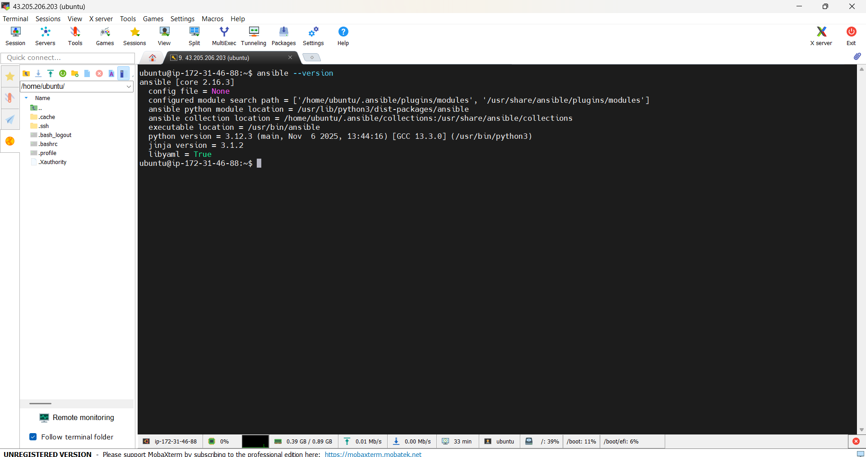

STEP 2 – Create Project Directory
A separate project directory was created to store Ansible configuration files.
mkdir l1-java-maven
cd l1-java-maven
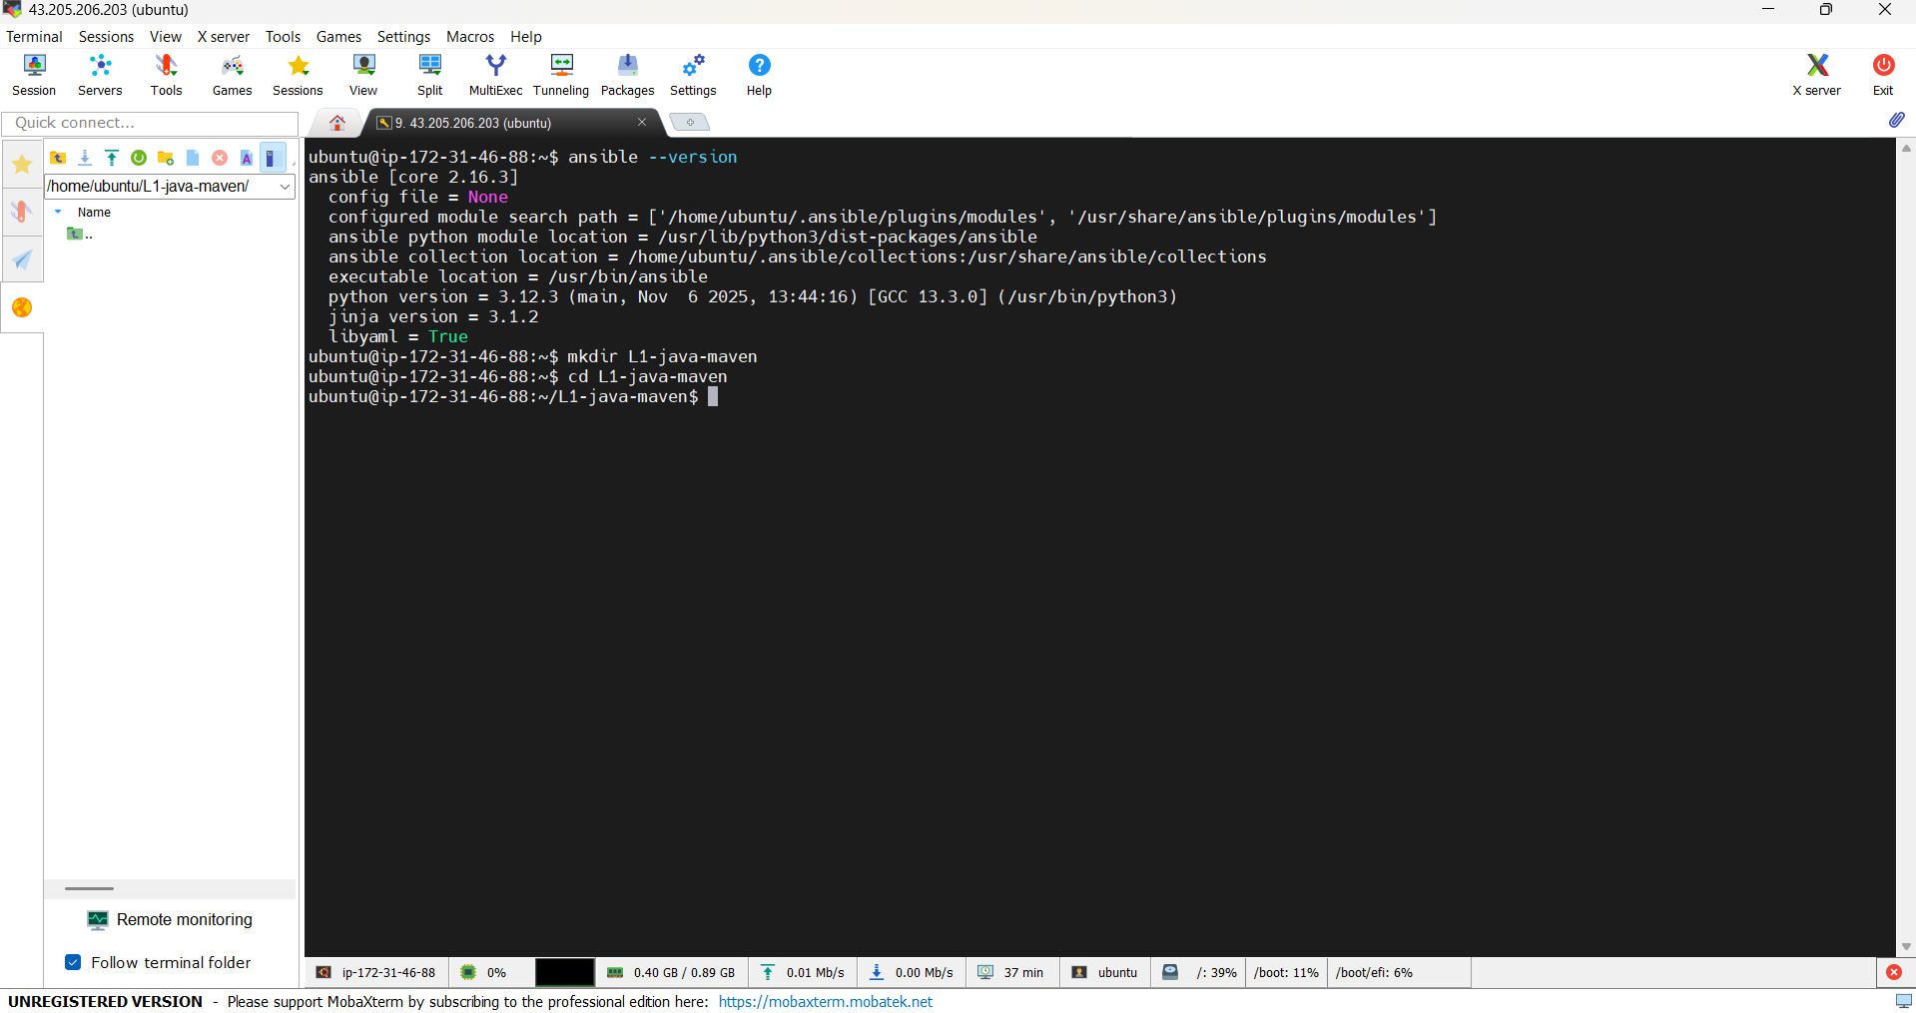

STEP 3 – Create Inventory File
Create file: vi inventory.ini
Paste this:
[java_server]
localhost
[java_server:vars]
ansible_connection=local

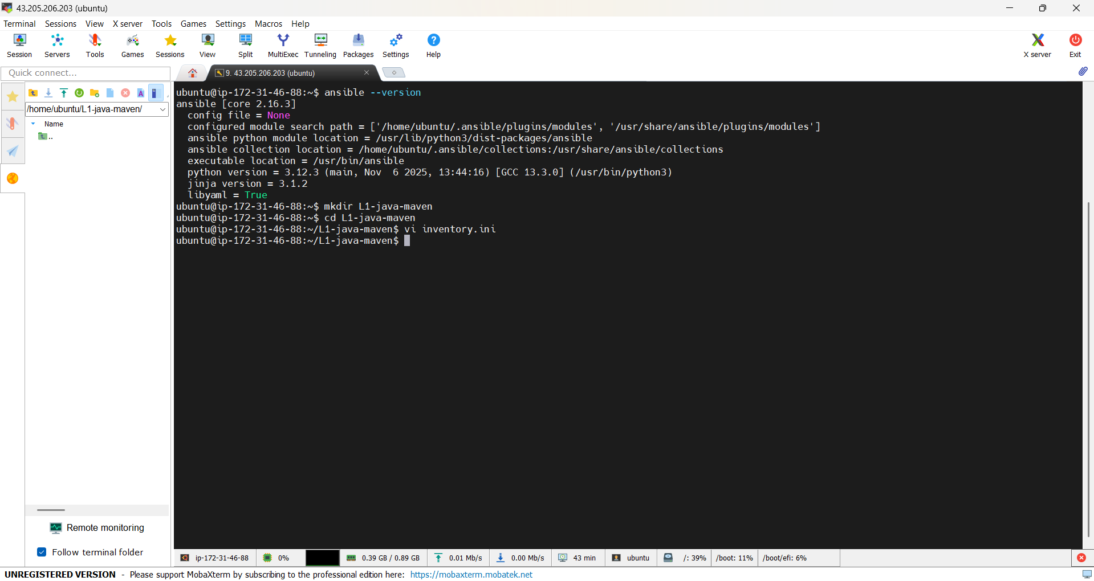
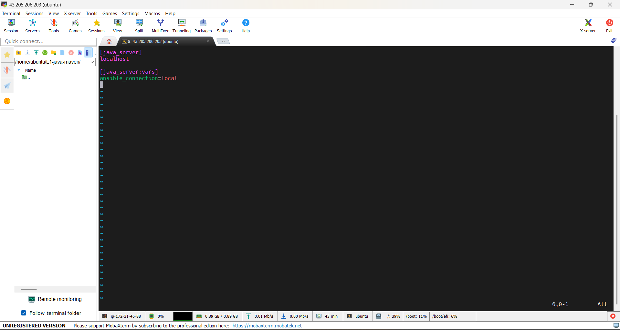

STEP 4 – Test Inventory Connectivity
ansible -i inventory.ini java_server -m ping
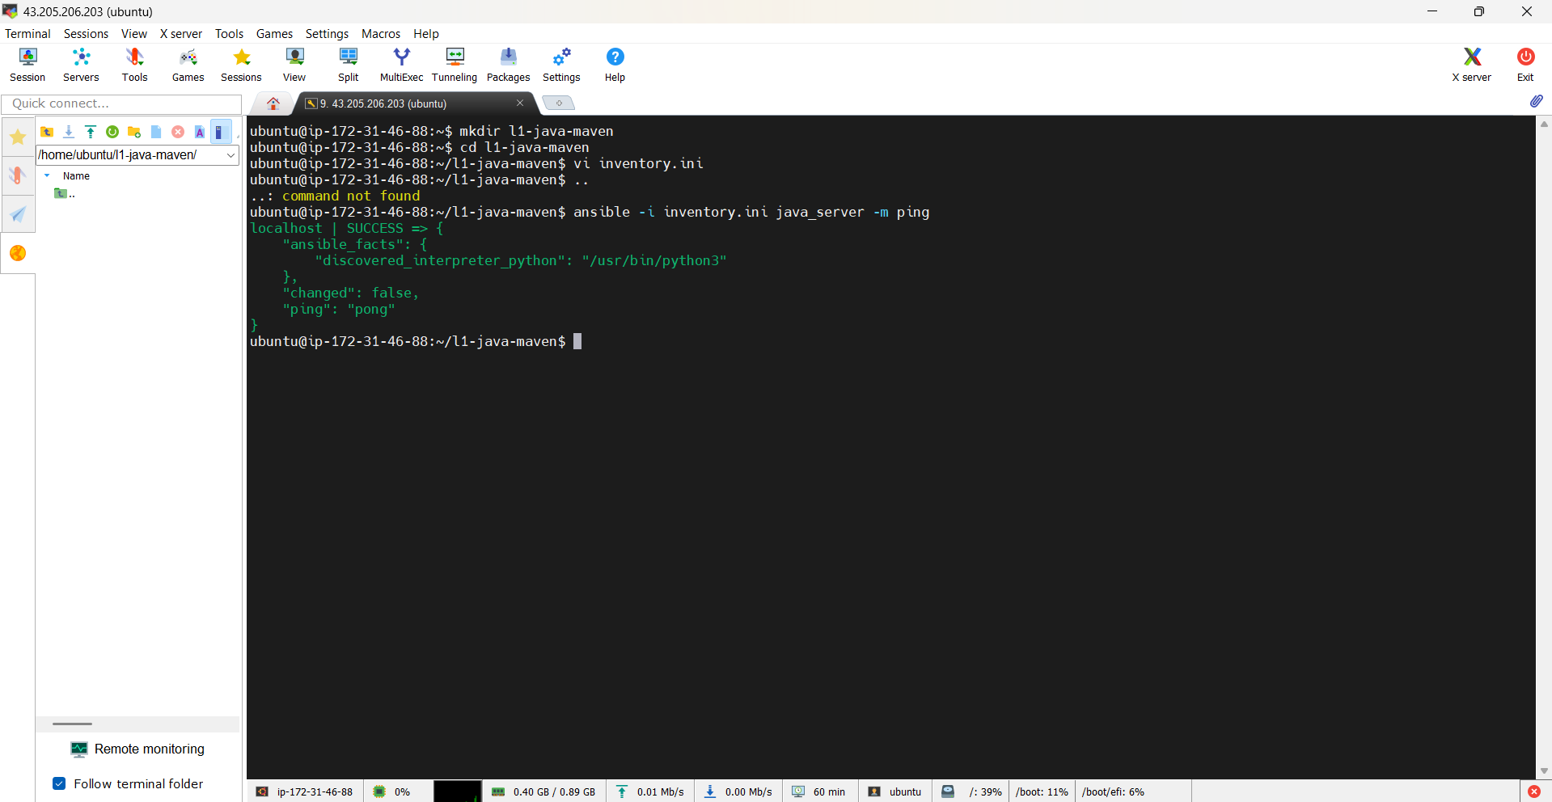

STEP 5 – Create Ansible Playbook
Create file: vi java-maven.yml
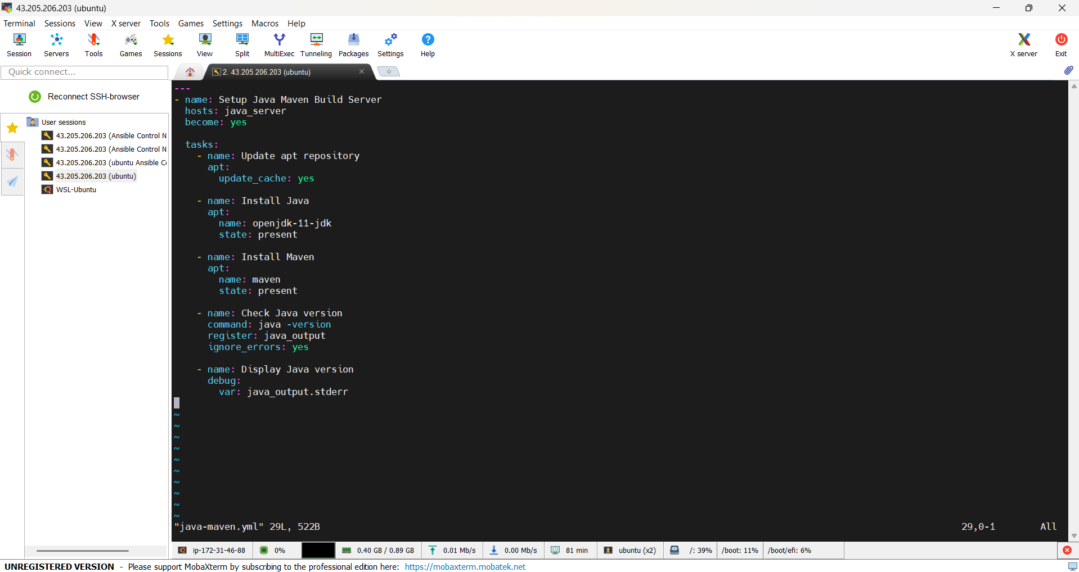

STEP 6 – Understand Each Line (VERY IMPORTANT)
hosts: java_server
➡ Run playbook on Java server group
become: yes
➡ Run tasks as root user
apt:
➡ Ubuntu package manager
state: present
➡ Install package if not installed
register
➡ Store command output
debug
➡ Print output on screen

STEP 7 – Execute Playbook
ansible-playbook -i inventory.ini java-maven.yml
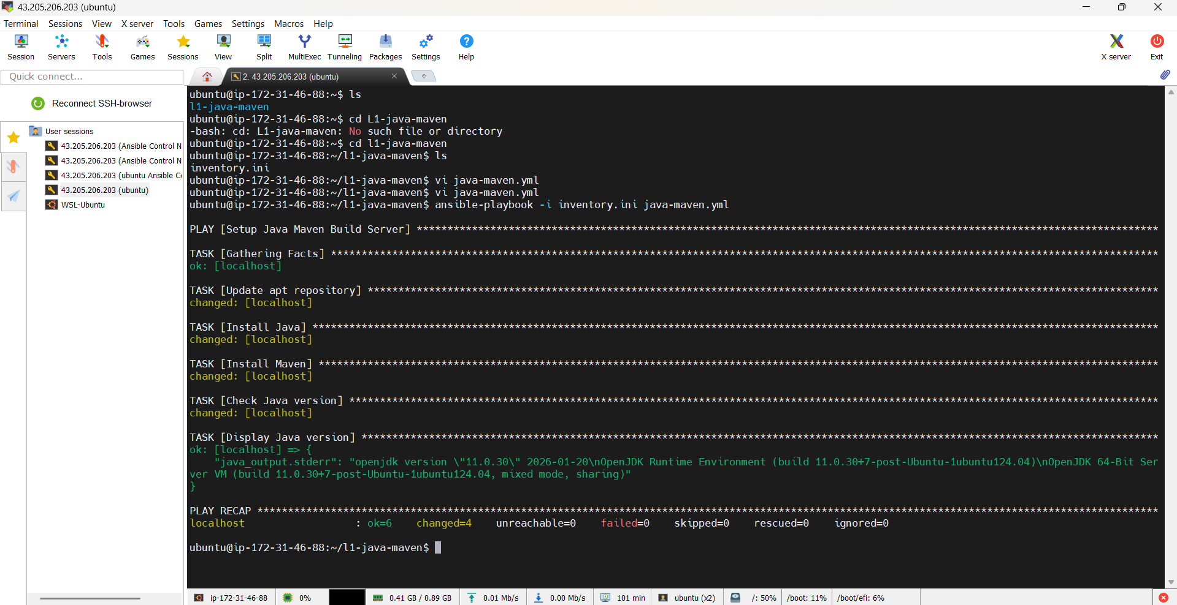

STEP 8 – Verify Installation
java -version
mvn -version
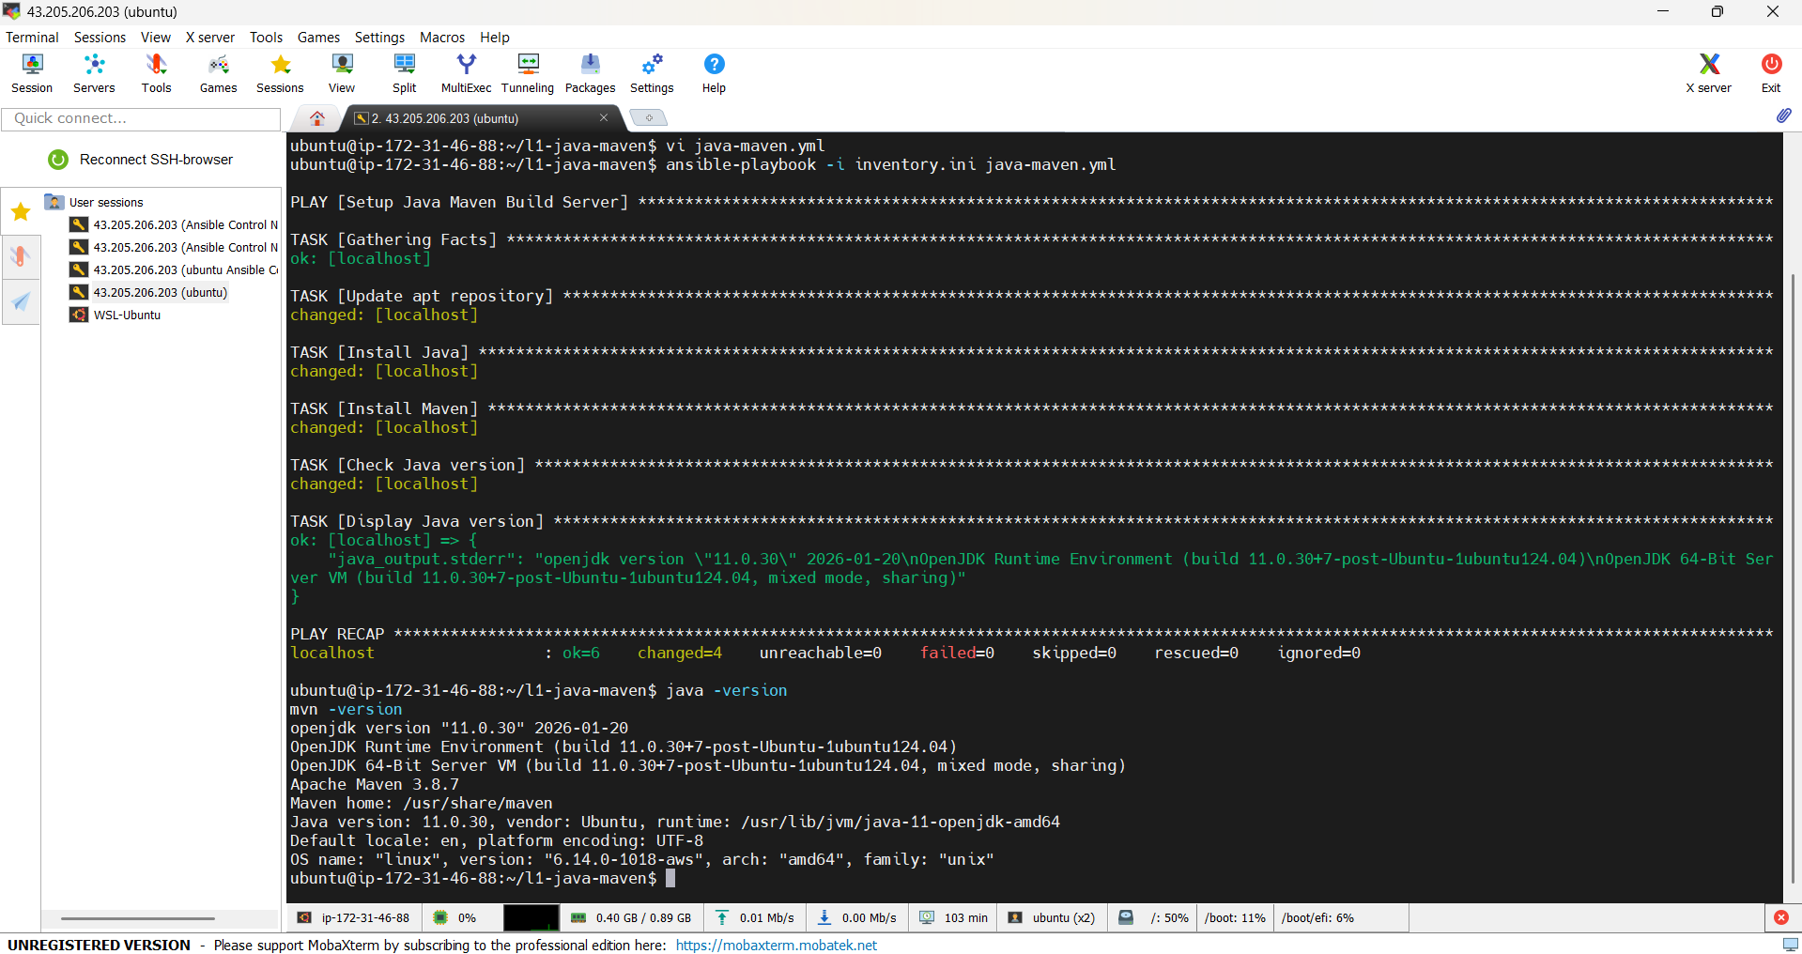

L2 - Create and Execute Ansible Playbook to Install Docker and Run the Docker Application Image created in Docker Module

STEP 1 – Login to EC2-1 (Control Node)
Using MobaXterm, connect to EC2-1.
ansible --version (we already did this in l1 because we are using the same ec2 instance we used in l1 so we know that we installed ansible in it)

STEP 2 – Create L2 Project Directory
mkdir l2-docker
cd l2-docker
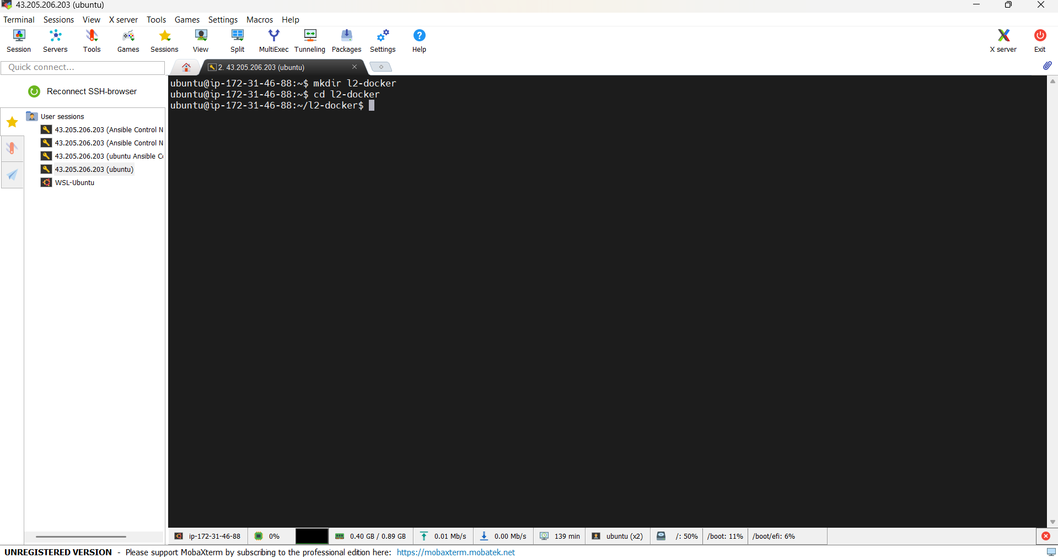

STEP 3 – Create Inventory File
Create file: vi inventory.ini
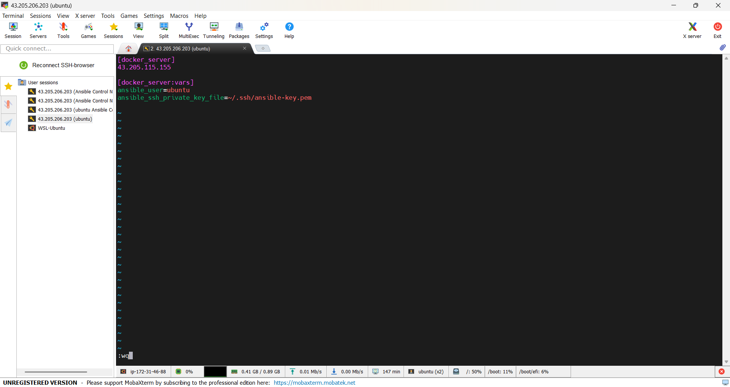

STEP 4 – Test SSH Connectivity
ansible -i inventory.ini docker_server -m ping
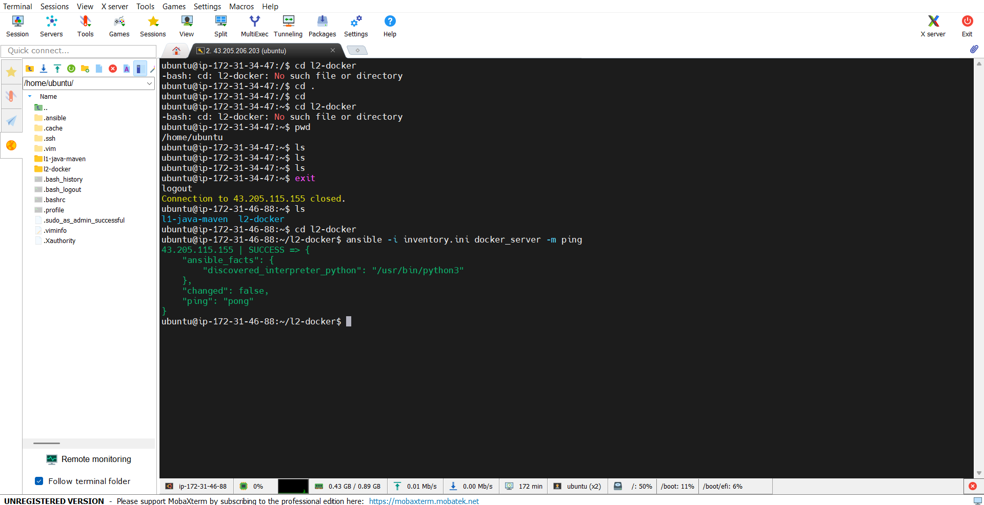

STEP 5 – Create Docker Playbook
vi docker-app.yml
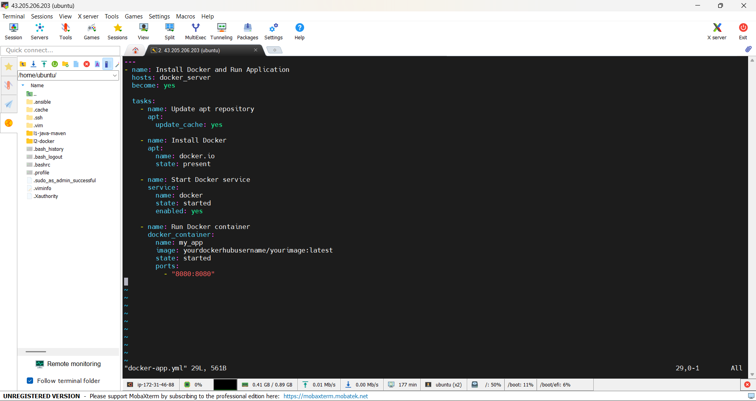

STEP 6 – Install Docker Collection (ON EC2-1)
ansible-galaxy collection install community.docker (I have already installed this)
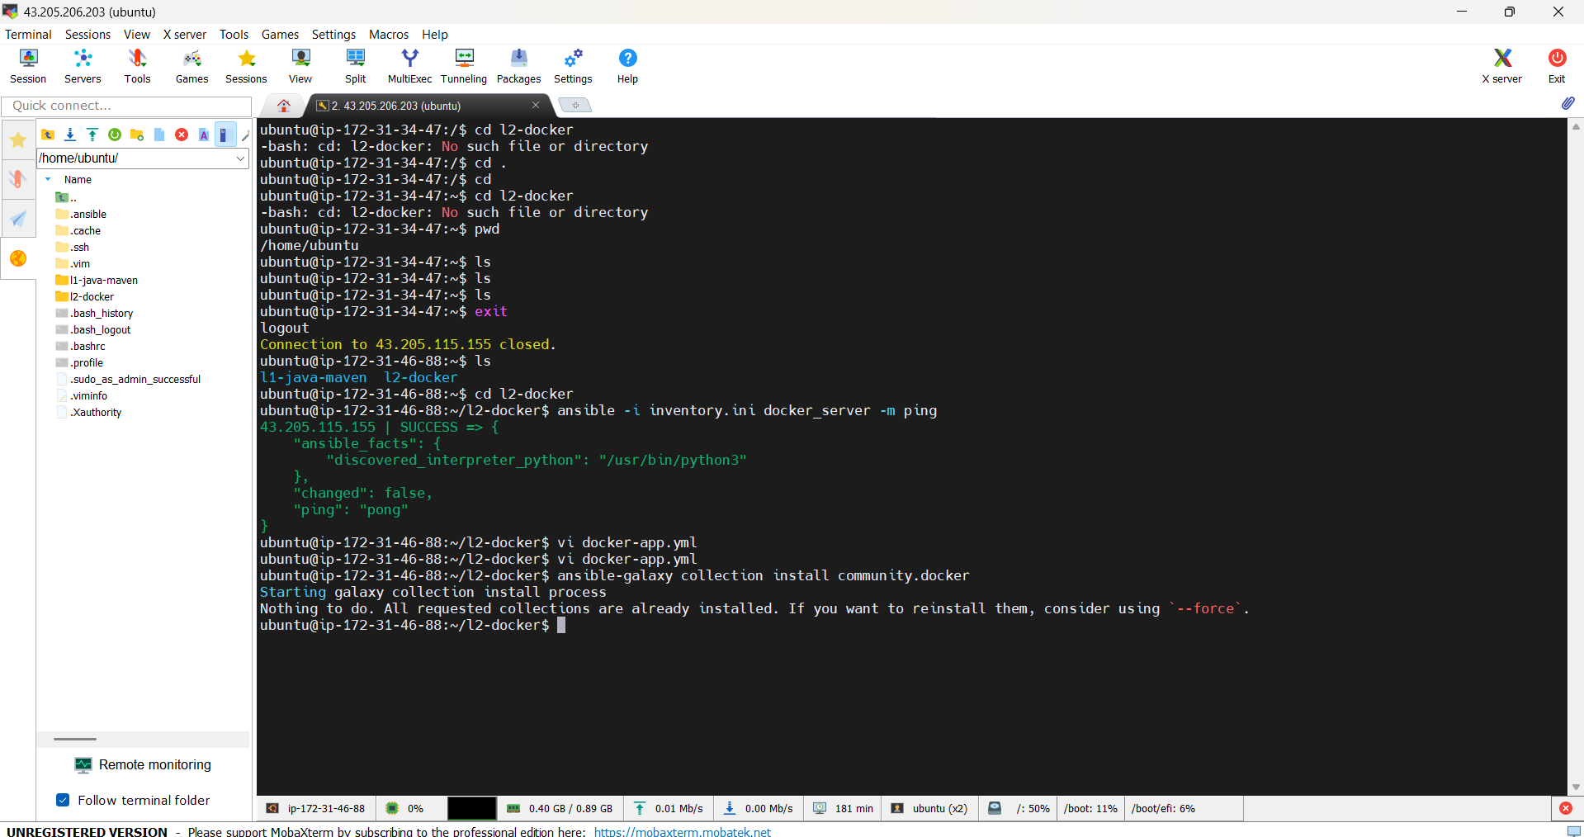

STEP 7 – Run Playbook
ansible-playbook -i inventory.ini docker-app.yml
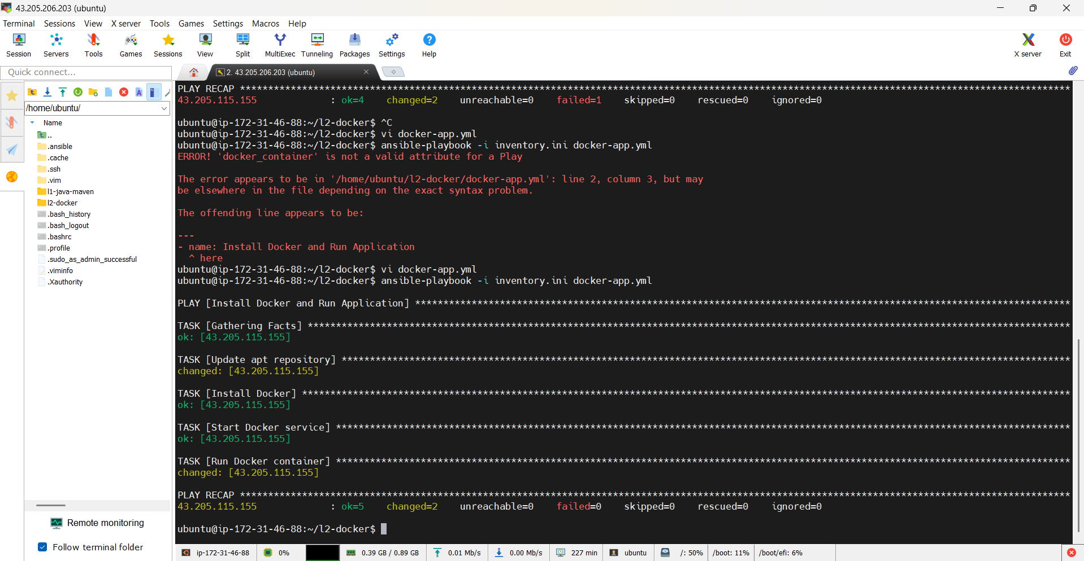

STEP 8 – Verify on EC2-3
Browser: http://EC2-3_PUBLIC_IP:8080
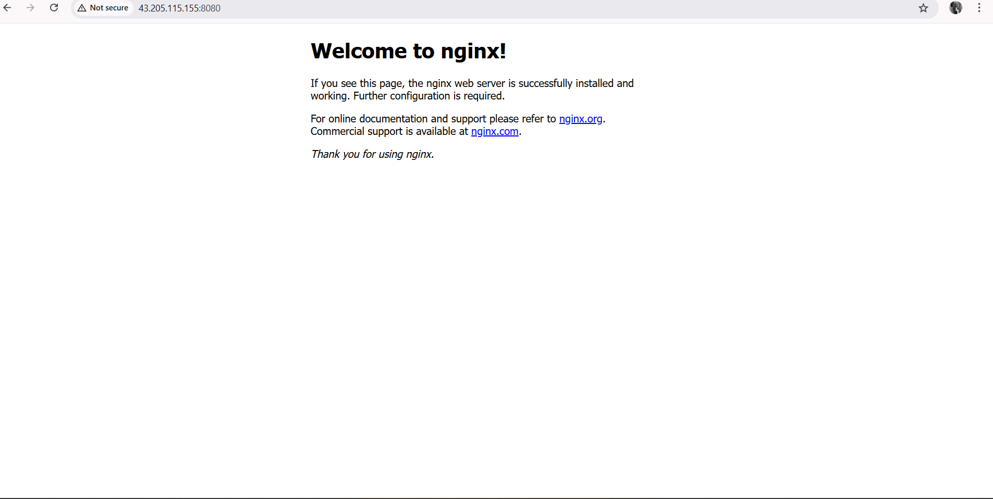

L3 - Create Ansible Role to define the task, handler for Nginx Service Installation and invoke the role in Ansible playbook

STEP 1 – Login to EC2-1 (Control Node)
Connect using MobaXterm.
ansible –version

STEP 2 – Create L3 Project Directory
mkdir l3-nginx-role
cd l3-nginx-role
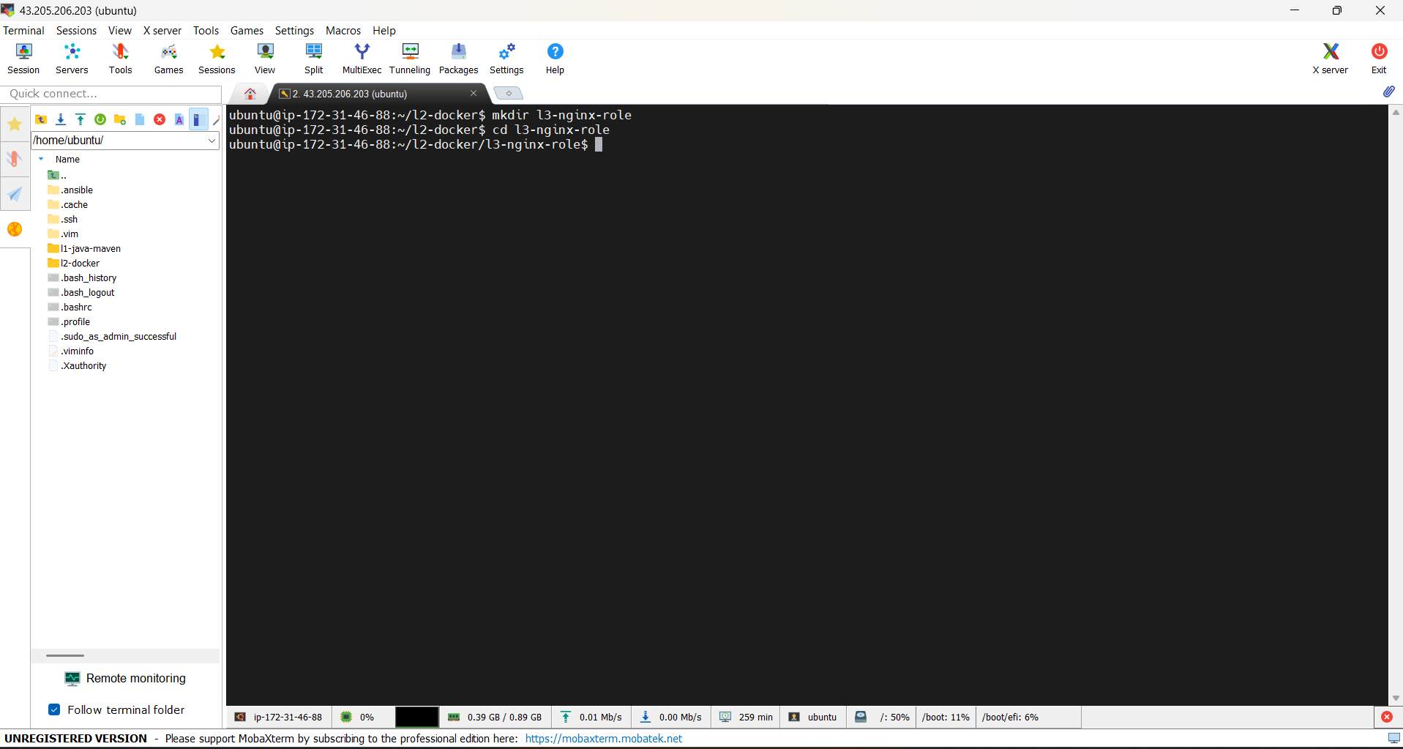

STEP 3 – Create Inventory File (Target = EC2-3)
vi inventory.ini
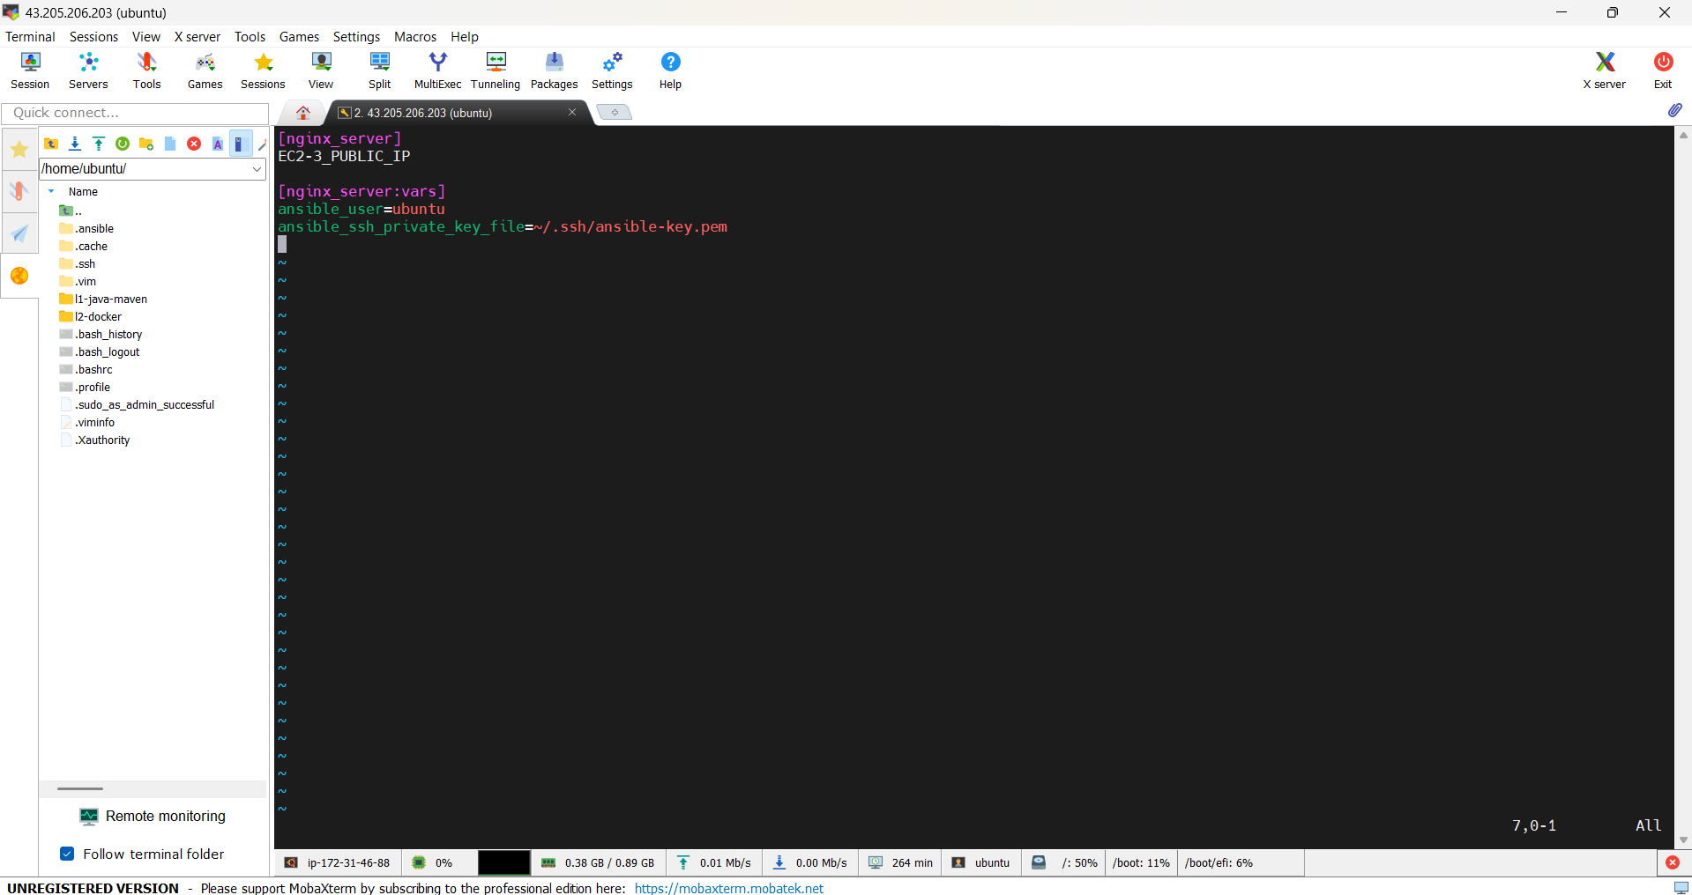

STEP 4 – Test Connectivity
ansible -i inventory.ini nginx_server -m ping
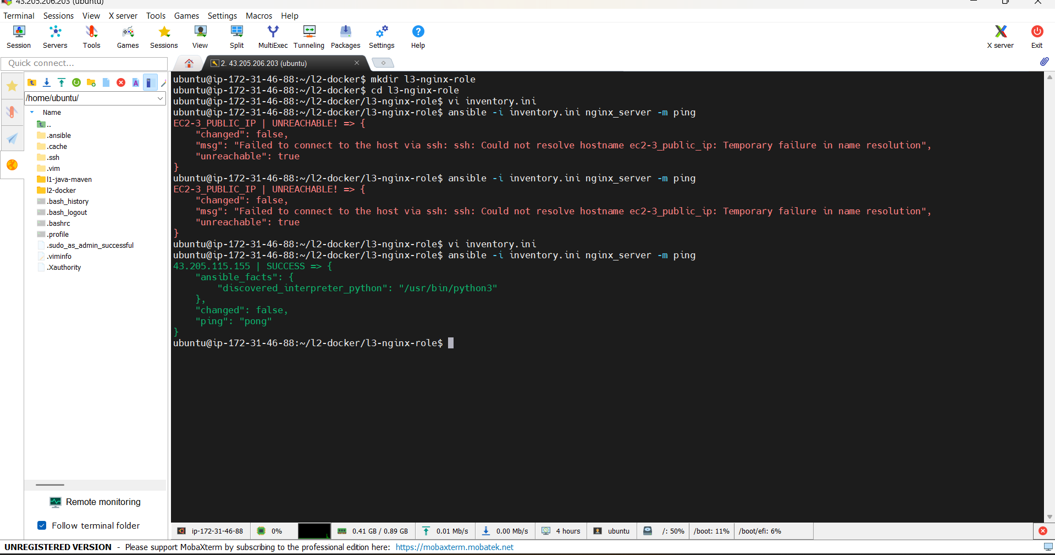

STEP 5 – Create Role Directory Structure
Run inside l3-nginx-role: mkdir -p roles/nginx/{tasks,handlers}
Check: tree
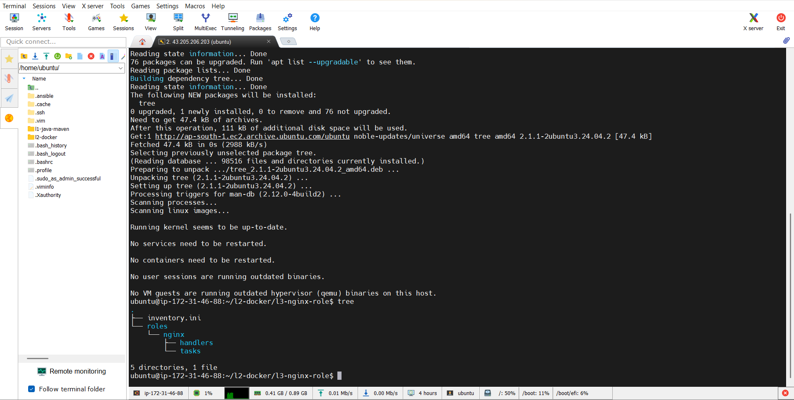

STEP 6 – Create Nginx Task File
vi roles/nginx/tasks/main.yml
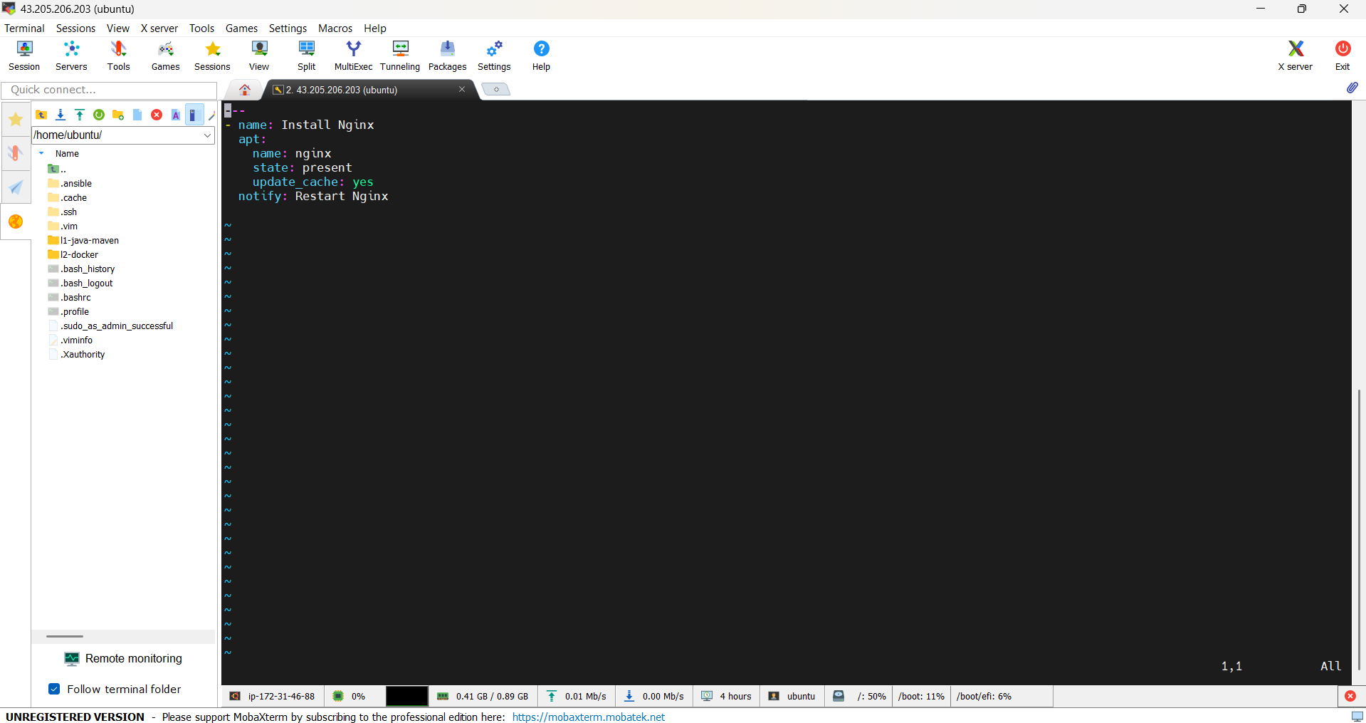

STEP 7 – Create Nginx Handler File
nano roles/nginx/handlers/main.yml
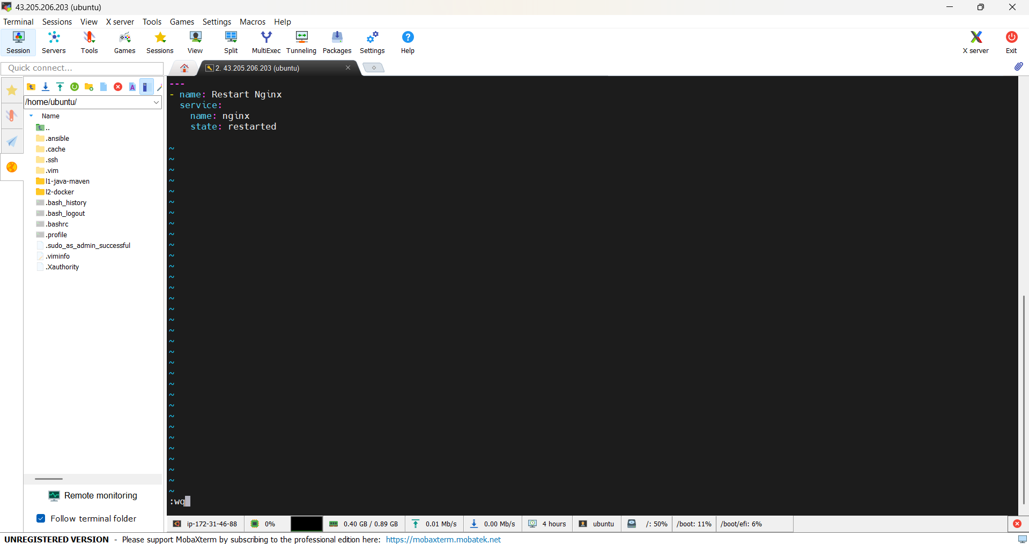

STEP 8 – Create Playbook to Invoke Role
vi nginx-role.yml
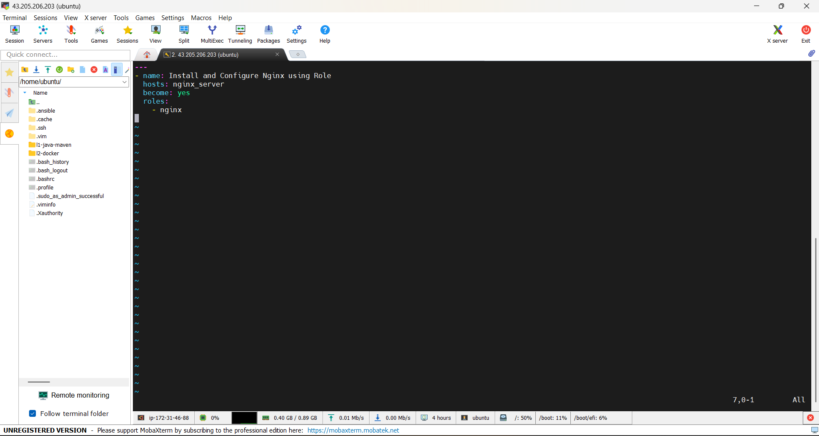

STEP 9 – Verify Directory Structure
tree
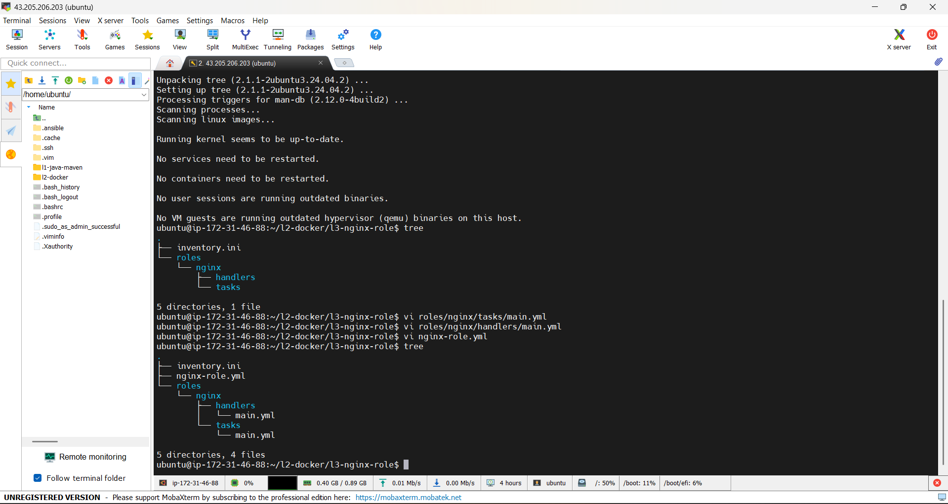

STEP 10 – Run L3 Playbook
ansible-playbook -i inventory.ini nginx-role.yml
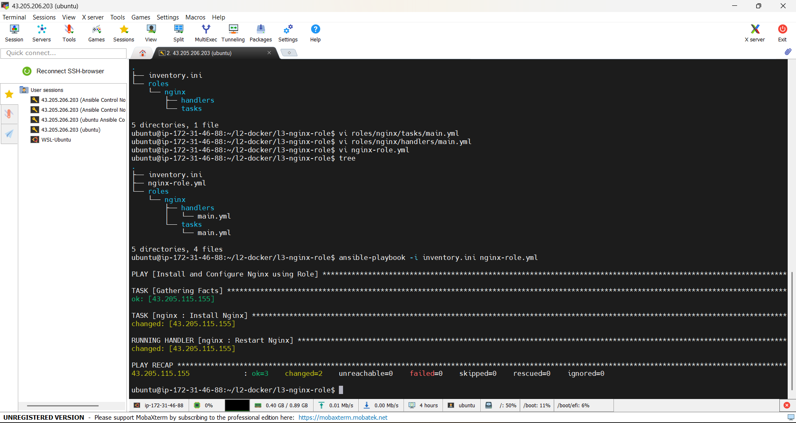

STEP 11 – Verify on EC2-3
Open browser: http://EC2-3_PUBLIC_IP
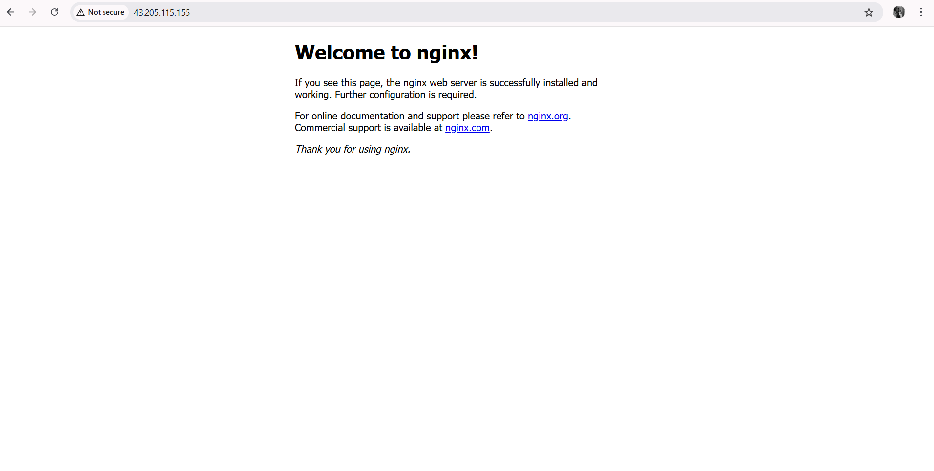
Conclusion:
This assignment demonstrates the practical implementation of configuration automation using Ansible on AWS EC2 infrastructure.
A dedicated Ansible control node was used to manage multiple EC2 managed nodes for automating Java & Maven setup, Docker-based application deployment, and Nginx service configuration.
The use of Ansible playbooks and roles highlights a clear understanding of infrastructure automation, configuration management, and service orchestration following real-world DevOps practices.
Overall, this assignment reflects hands-on experience with Ansible for automating multi-tier environments (L1, L2, and L3), aligning with industry expectations for DevOps and Cloud Engineer roles.

